**edible salt**

***1 :- Edible fine washed salt iodized or non iodized***

Details : all remain above 3 mm mesh with tolerance 5 % use s edible salt for food industrial

Packing : polypropylene packages each of 50 k.g or inside jumbo bags each of 1 ton or as customer request .

Specifications:

Sodium chloride(dry base)Nacl: 99.0-99.5%

Insoluble matter: 0.1 - 0.15%

Soluble matter: 0.40 - 0.85 %

Moisture:0.10 - 0.30 %

Bicarbonate:0.024 - 0.049 %

Sulphate: 0.30 - 0.55 %

Calcium: 0.04 - 0.13 %

Magnesium: 0.034 – 0.12 %

***2:- kitchen fine salt***

Refined iodized table salt or non iodized ,

All pass through 1mm mesh with tolerance 5%

Package:

Polyethlene package inside polypropylene one of 25 k.g , or polyethylene packages each of 400 gram or 200 gram ,, inside polypropylene one of 25 k.g , or inside carton box of 20 k.g , or polyethylene packages of self closing type each of 0.4 k.g . inside polypropylene one of 20 k.g or inside carton box 20 k.g.

Specifications: 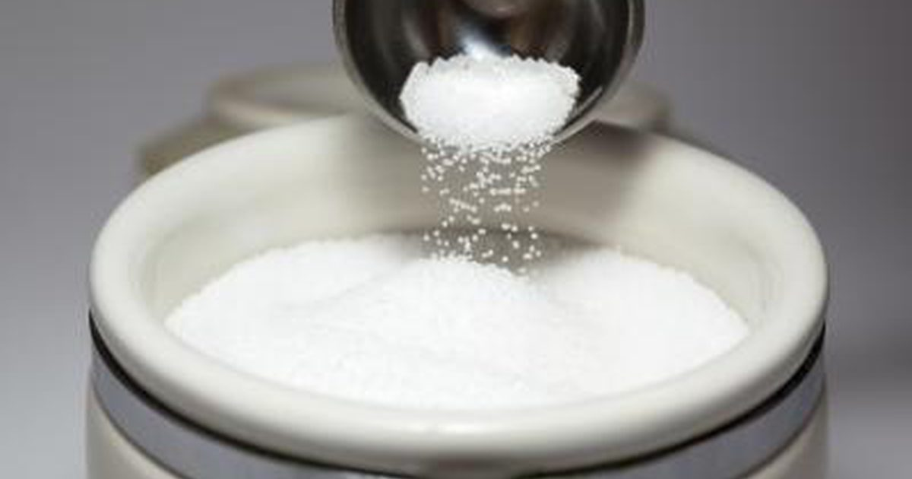

Sodium chloride(dry base)Nacl: 99.0-99.5%

Insoluble matter: 0.1 - 0.15%

Soluble matter: 0.40 - 0.85 %

Moisture:0.10 - 0.30 %

Bicarbonate:0.024 - 0.049 %

Sulphate: 0.30 - 0.55 %

Calcium: 0.04 - 0.13 %

Magnesium: 0.034 – 0.12 %

***3:- coarse kitchen salt ,***

Coarse kitchen salt all pass through 3mm mesh with the tolerance 5 % ,

Packages: polyethylene package inside polypropylene one of 25 k.g , or according to the customer request .

Specifications:-

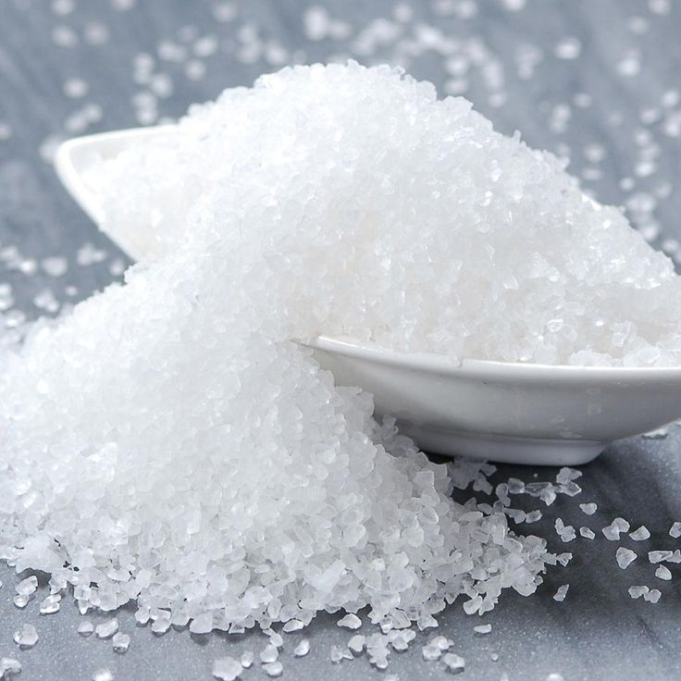

Insoluble matter: 0.1 - 0.15%

Soluble matter: 0.40 - 0.85 %

Moisture:0.10 - 0.30 %

Bicarbonate:0.024 - 0.049 %

Sulphate: 0.30 - 0.55 %

Calcium: 0.04 - 0.13 %

Magnesium: 0.034 – 0.12 %

**Production Of Ultra Pure Sodium Chloride Vacuum**

**The uses of Sodium Chloride (Vacuum) Salt**

Used for  haemodialysis solutions,Textile,food, Sodium Carbonate and Chloralkali industries

* Extra pure.
* Comply with the health and international regulations
* Reduce the time for the preparation of salt solution for medical purposes.
* Reduce the cost of the chemical treatment.

**Physical Properties:**

* Salt size: 0.01- 1.0 mm

**Chemical properties:**

* Sodium Chloride 99.5 % Min
* Water insoluble impurities ≤ 0.05%
* Water soluble impurities    ≤ 0.08%
* Moisture                           <0.2 %

5:- we also making salt for meat industrial in bags 25 k.g